Telemark Lone Worker How-To Questions? Barry Allen 250-575-6163 any time
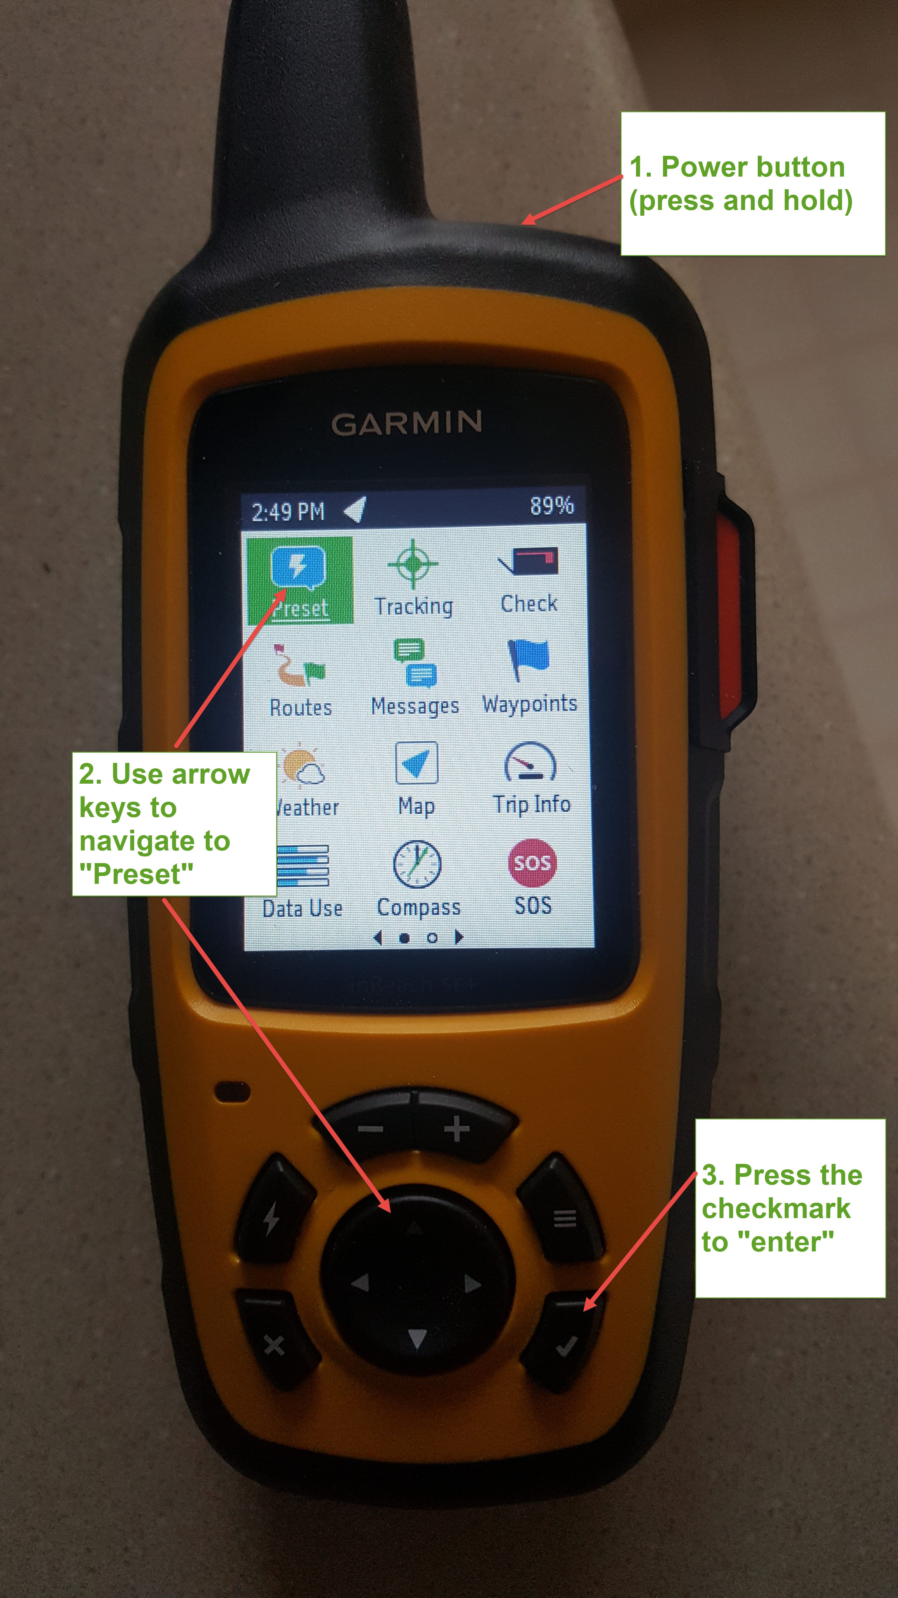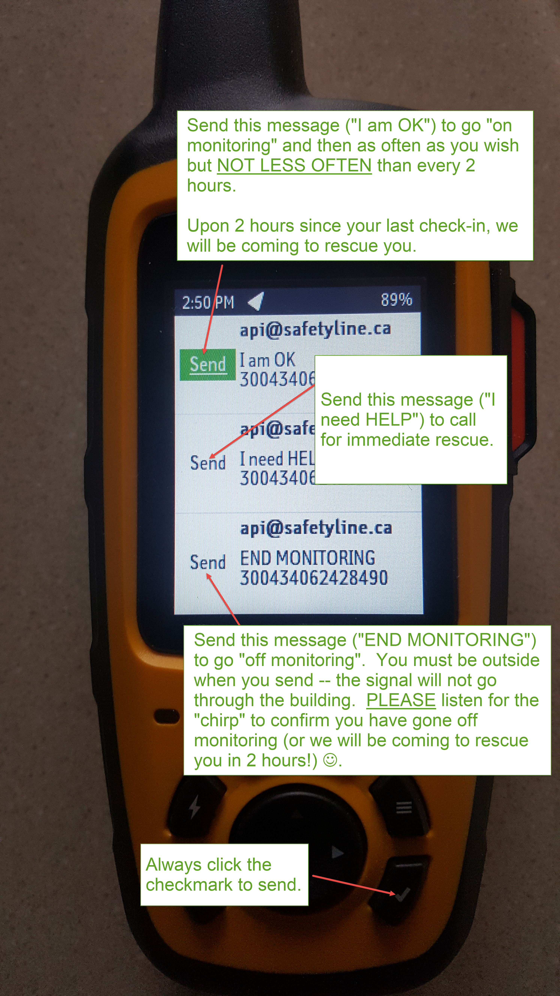
Note that you must sent the “End Monitoring” to clear the system! Turning the power off to the Garmin DOES NOT take you off monitoring!

Lone Worker System – For Monitors
This section contains the instructions for people designated as “monitors” in the Lone Worker monitoring system.
When someone goes “on monitoring” and does not check in for 2 hours, you will get an email and a phone call from SafetyLine. If you are in a position to deal with the emergency, then you must “acknowledge” the alarm. To do this, either reply to the email or type your code (last 4 digits of your phone number) into the phone.
To learn the location of the worker in distress, you must log in to SafetyLine. There is a link at the bottom of the web page to do this.
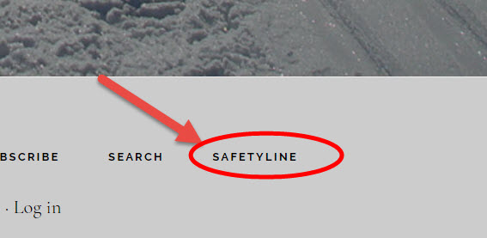
3. Log in to SafetyLine. Company ID is 422. User ID is the last 4 digits of your phone number. Your password will have been provided by the Telemark IT manager.
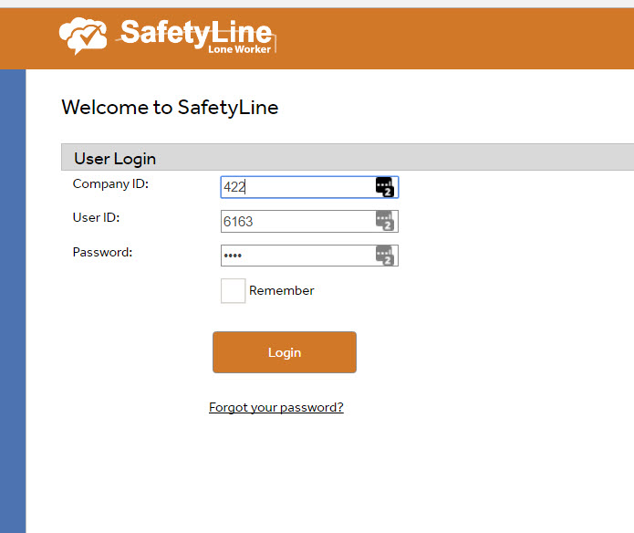
4. Check to see who initiated the emergency. It will be highlighted in a red band across the top of the screen.
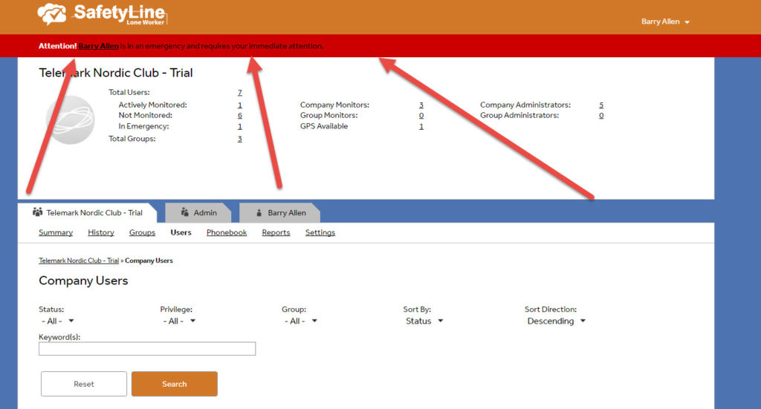
5. Click on the name to bring up the detail screen. This will display the recent reporting history for the worker in distress. Click on the flag icon to display the last reported location on a map.
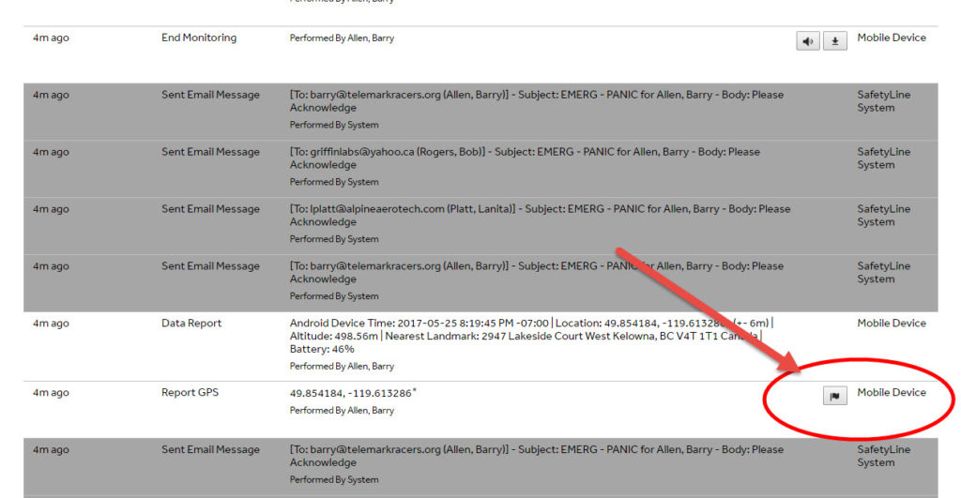
6. Off you go! Rescue in Progress.

