Ski School Details

Please arrive at least twenty minutes before your lesson to allow yourself time to get ready. All prices on this brochure include taxes. Payment should be made at the Telemark chalet office at the start of your first lesson by cash, debit or credit card. All drop-ins should book at least 24 hours in advance. Please try to call us the night before if you have to cancel.

For more detailed information, or to book a lesson email Chris Harmata at chrisjan@telus.net or 1-250-4920170, or call the Telemark chalet at 250-707-5925.

Telemark Nordic Ski School Improving Skiers One Skier at a Time
A non-profit sports club dedicated to fostering and promoting the sport of cross-country skiing, and other Nordic winter sports.

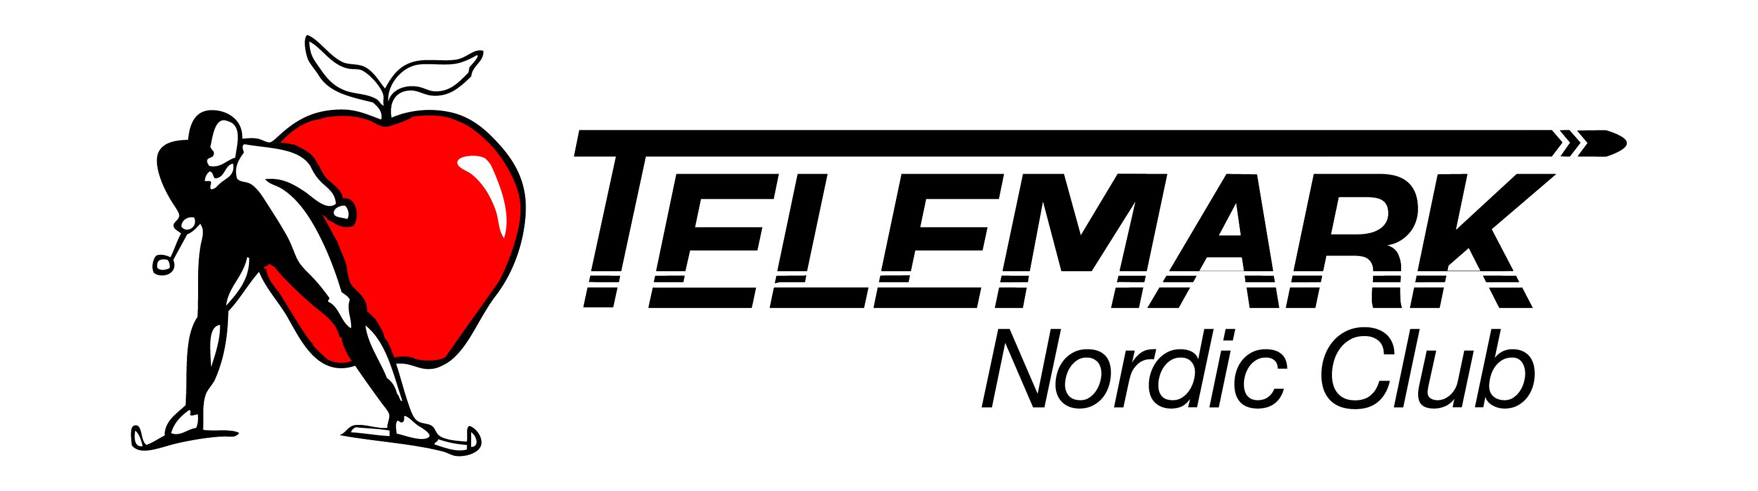
Telemark
PO Box 26072
West Kelowna, BC, V4T2G3
250-707-5925
tccsc@telus.net
www.telemarkx-c.com

Ski School Details

The Telemark Nordic Ski School is operated as a club program by Chris Harmata, a CANSI certified Level 2 certified CANSI instructor. Our ski instructors are CANSI certified, and are dedicated to improving your skiing. You will build confidence, control and efficiency by learning sound skate or classic ski techniques. Lesson times are flexible so that they fit your schedule. The Ski School lessons are for beginner to advanced skiers. You can come on your own or get a group together for a fun day on the snow.
The lesson rates are as follows:

Private $50 (1 on 1)
Semi-Private $40 each (2 people)
Group $30 each (3-8 people)

All lessons are 75 minutes in duration. The prices do not include the required ski trail pass or equipment. Rental equipment is available at regular rental rates. A classic ski, pole and boot package is $15 and a skate ski, pole and boot package is $20. All lessons are 75 minutes in duration.

Discover Cross Country Skiing - Clinics – The popular adult clinics are for people who have taken a lesson or skied before, and are looking to improve their skills and technique, so they can enjoy skiing for fun and fitness. These sessions take place on 3 consecutive Saturday or Sunday afternoons starting at 2:30, for 90 minutes. Both skate and classic technique are offered with the skate clinics taking place on Saturdays and the classic clinics on Sundays. The cost is $ 85 (taxes included). The prices do not include the required ski pass or equipment. If you are not a season pass holder you will be required to purchase a trail pass. Rental equipment is available at regular rental rates. A classic ski, pole and boot package is $ 15 and a skate ski, pole and boot package is $ 20.



